Lab 2: Transient Analysis of Bandgap (BG) Voltage Reference

Background:
Start-up circuit is needed in order to ensure the proper operation of Bandgap Voltage Reference. Most of the circuit block also has a shunt-down pin designed. This allows the circuit block to be power down to save power when necessary. Transient analysis is needed to simulate the proper operation of the start-up circuit and shunt-down pin.

Objectives:
- Familiarisation with transient simulation for a BG Voltage Reference Circuit
- Understanding of the operation of start-up circuit for BG Voltage Reference

- Transient Simulation

  - In Library Manager, double-click BG_OPAMP/BG_test_TRAN. This is the test bench to test the start up and shut down performance of the circuit.
  - In BG_test_TRAN schematic, click Launch>ADE_L.
  - In ADE, click session>Load_State. Check ‘cellview’ and select BG_OPAMP/BG_test_TRAN/spectre-state1. Click OK.
  - Launch the simulation.

- Result of transient simulation

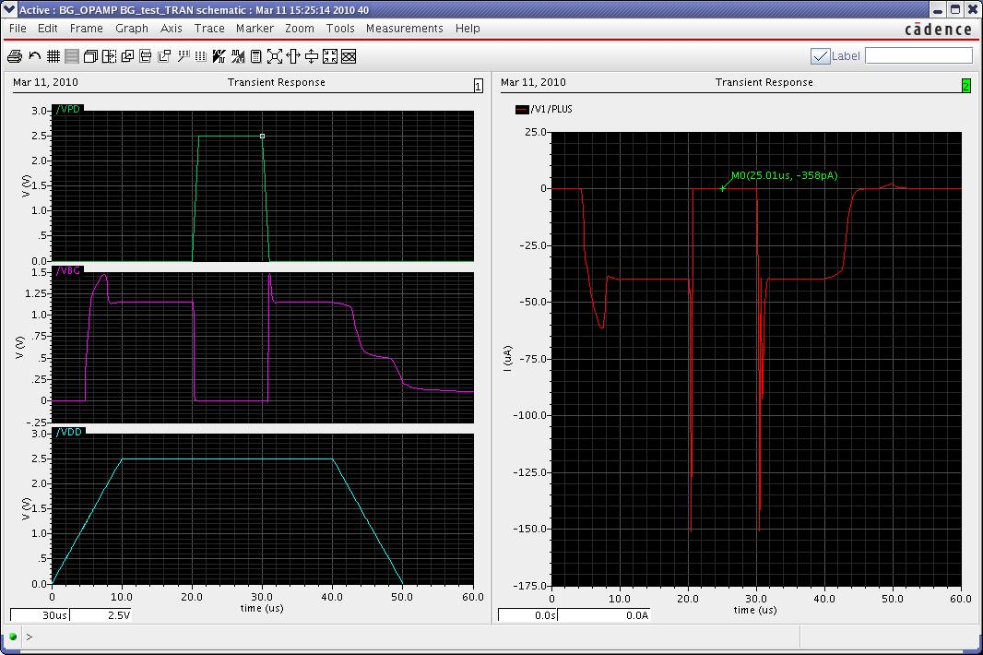
Figure 1: Result of transient simulation

  - Create a new subwindow and drag /V1/PLUS to it. /V1/PLUS is the supply current of the circuit.
  - Click on the left subwindow to select it. Click on ‘Strip_chart_mode’.
  - Click on the trace /V1/PLUS of right subwindow. Click Marker>Place>Track_Marker and click on the trace /V1/PLUS, to place the marker. It is observed that the current consumption is <1nA when the circuit is shut-down.
  - More simulation, with different conditions, such as different VDD, process corners, temperatures, risetime of VDD and etc., should be performed to ensure that the design is robust.
  - As an exercise, please identify the start-up circuit of the bandgap and understand its operating principle.

